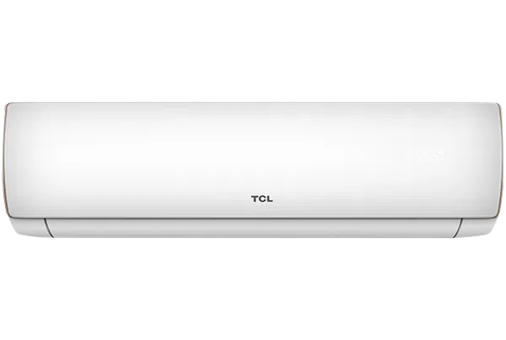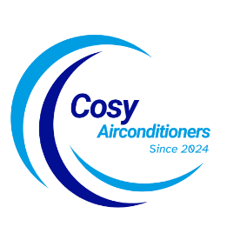

SKU: TSU-18HFCF/013USDC (W)

**Miracle Series Inverter**

~~Rs 145,999.00~~Rs 131,999.00

7 Air flow control

Full BTU in high temperature

One touch self cleaning

With adoption of optimized cooling system, the cooling capacity of Haier Air Conditioners still could catch up 100% to provide the best cooling experience to user at 46◦C high temperature.

**Product details**

**THANK YOU!**

**WELLCOME TO OUR WEBSITE**